CAMHS Phoenix School
Behaviour policy and statement of behaviour principles



Written | January 2023
Responsibility | Kate Sumner
Shared with team | January 2025
Approved by Management Committee | February 2023
Next Review Date | May 2027
Reviewed by Management Committee (RJ and NR) | January 2025, May 2025, HT May 2026

Version | DATE | DESCRIPTION
2 | Jan 2024 | minor amendments to wording
3 | September 2024 | Added 6.2 re vaping
4 | February 2025 | Added Therapeutic thinking statement, changed wording to reflect Therapeutic Thinking approach.
 | May 2025 | No amendments
 | May 2026 | No amendments

Contents
1. Aims 2
2. Legislation, statutory requirements and statutory guidance 2
3. Definitions 3
4. Bullying 3
5. Roles and responsibilities 4
6. School behaviour curriculum 6
7. Responding to behaviour 6
8. Serious sanctions 10
9. Responding to misbehaviour from pupils with SEND 11
10. Supporting pupils following a sanction 12
11. Pupil transition 12
12. Training 12
13. Monitoring arrangements 12
14. Links with other policies 13
Appendix 1: written statement of behaviour principles 14
Appendix 2: behaviour log of incident 16
Appendix 3: letters to parents about pupil behaviour - templates 17

1. Aims
This policy aims to:
- Create a positive culture that promotes excellent behaviour, ensuring that all pupils have the opportunity to learn in a calm, safe and supportive environment
- Establish a whole-school approach to maintaining high standards of behaviour that reflect the values of the school
- Outline the expectations and consequences of behaviour
- Provide a consistent approach to behaviour management that is applied equally to all pupils
- Define what we consider to be unacceptable behaviour, including bullying and discrimination

Therapeutic Thinking
We are a Therapeutic Thinking school. We are all trained in Therapeutic Thinking and this underpins all of our interactions with our young people. We aim to understand what a young person is trying to communicate with their behaviour and support them with their difficulties. We do not use a punitive system but support our young people through understanding, listening and teaching. Once we have analysed their behaviour we plan how we can support them and manage situations proactively.

2. Legislation, statutory requirements and statutory guidance
This policy is based on legislation and advice from the Department for Education (DfE) on:
- Behaviour and discipline in schools: advice for headteachers and school staff, 2016
- Behaviour in schools: advice for headteachers and school staff 2022
- Searching, screening and confiscation at school 2018
- Searching, screening and confiscation: advice for schools 2022
- The Equality Act 2010
- Keeping Children Safe in Education
- Exclusion from maintained schools, academies and pupil referral units in England 2017
- Suspension and permanent exclusion from maintained schools, academies and pupil referral units in England, including pupil movement - 2022
- Use of reasonable force in schools
- Supporting pupils with medical conditions at school
It is also based on the Special Educational Needs and Disability (SEND) Code of Practice.
In addition, this policy is based on:
- Section 175 of the Education Act 2002, which outlines a school’s duty to safeguard and promote the welfare of its pupils
- Sections 88 to 94 of the Education and Inspections Act 2006, which requires schools to regulate pupils’ behaviour and publish a behaviour policy and written statement of behaviour principles, and give schools the authority to confiscate pupils’ property
- DfE guidance explaining that maintained schools must publish their behaviour policy online

3. Definitions
Challenging behaviour is defined as:
- Disruption in lessons
- Persistent refusal to complete classwork
- Inappropriate use of technology- see AUP
Serious challenging behaviour is defined as:
- Repeated breaches of the school rules
- Any form of bullying
- Sexual violence, such as rape, assault by penetration, or sexual assault (intentional sexual touching without consent)
- Sexual harassment, meaning unwanted conduct of a sexual nature, such as:
- Sexual comments
- Sexual jokes or taunting
- Physical behaviour like interfering with clothes
- Online sexual harassment, such as unwanted sexual comments and messages (including on social media), sharing of nude or semi-nude images and/or videos, or sharing of unwanted explicit content
- Vandalism
- Theft
- Fighting
- Racist, sexist, homophobic or discriminatory behaviour

4. Bullying
Bullying is defined as the repetitive, intentional harming of 1 person or group by another person or group, where the relationship involves an imbalance of power.
Bullying is, therefore:
- Deliberately hurtful
- Repeated, often over a period of time
- Difficult to defend against
Bullying can include:
TYPE OF BULLYING | DEFINITION
Emotional | Being unfriendly, excluding, tormenting
Physical | Hitting, kicking, pushing, taking another’s belongings, any use of violence
Prejudice-based and discriminatory, including:  - Racial  - Faith-based  - Gendered (sexist)  - Homophobic/biphobic  - Transphobic  - Disability-based | Taunts, gestures, graffiti or physical abuse focused on a particular characteristic (e.g. gender, race, sexuality)
Sexual | Explicit sexual remarks, display of sexual material, sexual gestures, unwanted physical attention, comments about sexual reputation or performance, or inappropriate touching
Direct or indirect verbal | Name-calling, sarcasm, spreading rumours, teasing
Cyber-bullying | Bullying that takes place online, such as through social networking sites, messaging apps or gaming sites

See also CAMHS Phoenix anti- bullying policy.

5. Roles and responsibilities
5.1 The Management Committee
The Management Committee is responsible for:
- Reviewing and approving the written statement of behaviour principles (appendix 1)
- Reviewing this behaviour policy in conjunction with the headteacher
- Monitoring the policy’s effectiveness
- Holding the headteacher to account for its implementation
5.2 The headteacher
The headteacher is responsible for:
- Reviewing this policy in conjunction with the Management Committee
- Giving due consideration to the school’s statement of behaviour principles (appendix 1)
- Approving this policy
- Ensuring that the school environment encourages positive behaviour
- Ensuring that staff deal effectively with poor behaviour
- Monitoring that the policy is implemented by staff consistently with all groups of pupils
- Ensuring that all staff understand the behavioural expectations and the importance of maintaining them
- Providing new staff with a clear induction into the school’s behavioural culture to ensure they understand its rules and routines, and how best to support all pupils to participate fully
- Offering appropriate training in behaviour management, and the impact of special educational needs and disabilities (SEND) and mental health needs on behaviour, to any staff who require it, so they can fulfil their duties set out in this policy
- Ensuring this policy works alongside the safeguarding policy to offer pupils both sanctions and support when necessary
- Ensuring that behaviour records are reviewed regularly, to make sure that no groups of pupils are being disproportionately impacted by this policy (see section 13.1)
5.3 Teachers and staff
Staff are responsible for:
- Creating a calm and safe environment for pupils
- Establishing and maintaining clear boundaries of acceptable pupil behaviour
- Implementing the behaviour policy consistently
- Communicating the school’s expectations, routines, values and standards through teaching behaviour and in every interaction with pupils
- Modelling expected behaviour and positive relationships
- Providing a personalised approach to the specific behavioural needs of particular pupils e.g breaking activities into small parts, allowing for movement breaks and rest breaks.
- Considering their own behaviour on the school culture and how they can uphold school rules and expectations
- Recording behaviour incidents promptly – in progress notes and on RiO in nursing notes, shared with MDT.
- Reminding pupils to meet the school’s expectations
- Completing training in understanding mental health conditions and how to support young people.

The senior leadership team (SLT) will support staff in responding to behaviour incidents.
5.4 Parents and carers
Parents and carers, where possible, should:
- Get to know the school’s behaviour policy and reinforce it at home where appropriate. The policy is available on the school website
- Support their child in adhering to the school’s behaviour policy
- Inform the unit of any changes in circumstances that may affect their child’s behaviour
- Discuss any behavioural concerns with the school staff
- Raise any concerns about the management of behaviour with the school directly, whilst continuing to work in partnership with the school
- Take part in the life of the school and its culture
The school will endeavour to build a positive relationship with parents and carers by keeping them informed about developments in their child's behaviour and the school’s policy, and working in collaboration with them to tackle behavioural issues.
5.5 Pupils
Pupils will be made aware of the following during their induction:
- The expected standard of behaviour they should be displaying at school
- That they have a duty to follow the classroom code of conduct
- The school’s key rules and routines
- The rewards they can earn for meeting the behaviour standard, and the consequences they will face if they don’t meet the standard
- The pastoral support that is available to them to help them meet the behavioural standards e.g. 1:1 support from key nurse, psychologist, link clinician.
Pupils will be supported to meet the behaviour standards and will be provided with repeated induction sessions wherever appropriate.
Pupils will be supported to develop an understanding of the school’s behaviour policy and wider culture.
Pupils will be asked to give feedback on their experience of the behaviour culture to support the evaluation, improvement and implementation of the behaviour policy.

6. School behaviour curriculum
Pupils are expected to:
- Show respect to members of staff and each other
- In class, make it possible for all pupils to learn
- Move quietly around the school
- Treat the school buildings and school property with respect
- Accept sanctions when given
- Refrain from behaving in a way that brings the school into disrepute, including when outside school or online
Where appropriate and reasonable, adjustments may be made to routines within the curriculum to ensure all pupils can meet behavioural expectations in the curriculum.
6.1 Mobile phones
Pupils are not allowed to bring mobile phones into the school building unless there are exceptional circumstances. Mobile phones are left in lockers before entering the school building.
6.2 Vaping
Smoking or vaping is not permitted on any part of the unit site at any time. If a young person brings a vape or smoking equipment to the unit it will be removed during the search process on entry and returned at the end of the day.

7. Responding to behaviour
7.1 Classroom management
Teaching and support staff are responsible for setting the tone and context for positive behaviour within the school.
They will:
- Create and maintain a stimulating environment that encourages pupils to be engaged
- Display classroom code of conduct,
- Explain Code of Conduct on admission
- Develop a positive relationship with pupils, which may include:
  - Greeting pupils in the morning/at the start of lessons
  - Establishing clear routines
  - Communicating expectations of behaviour in ways other than verbally
  - Highlighting and promoting good behaviour
  - Concluding the day positively and starting the next day afresh
  - Having a plan for dealing with low-level disruption
  - Using positive reinforcement where appropriate
  - Delivering engaging lessons
  - Maintaining a calm, quiet teaching area
  - Breaking longer activities into small chunks and allowing movement breaks and rest breaks
  - Use of a quiet space for time out
  - Regularly auditing our teaching areas for their appropriateness for neurodivergent young people
  - Liaising with the wider unit team to understand needs and useful strategies
7.2 Safeguarding
The school recognises that changes in behaviour may be an indicator that a pupil is in need of help or protection.
We will consider whether a pupil’s misbehaviour may be linked to them suffering, or being likely to suffer, significant harm.
Where this may be the case, we will follow our child protection and safeguarding policy, and consider whether pastoral support, an early help intervention or a referral to children’s social care is appropriate.
Please refer to our safeguarding policy for more information.
7.3 Responding to good behaviour
When a pupil’s behaviour meets or goes above and beyond the expected behaviour standard, staff will recognise it with positive recognition and reward. This provides an opportunity for all staff to reinforce the school’s culture and ethos.
Positive reinforcements and rewards will be applied clearly and fairly to reinforce the routines, expectations and norms of the school’s behaviour culture.
Positive behaviour will be rewarded in line with the needs of each pupil.
This may be with:
Verbal praise
Stamps on work
Work displayed in class
Celebrations in community meetings
Communication with medical team, parents or others
Certificates or prizes
7.4 Responding to inappropriate behaviour
When a pupil’s behaviour falls below the standard that can reasonably be expected of them, staff will respond in order to restore a calm and safe learning environment, and to prevent recurrence of the inappropriate behaviour.
Staff will endeavour to create a predictable environment by always challenging behaviour that falls short of the standards, and by responding in a consistent, fair and proportionate manner, so pupils know with certainty that misbehaviour will always be addressed.
De-escalation techniques can be used to help prevent further behaviour issues arising, such as the use of pre-arranged scripts and phrases.
All pupils will be treated equitably under the policy, with any factors that contributed to the behavioural incident identified and taken into account.
When giving behaviour sanctions, staff will also consider what support could be offered to a pupil to help them to meet behaviour standards in the future.
The school may use 1 or more of these strategies in response to unacceptable behaviour:
- Asking the pupil to move to a different seat/room
- A verbal reprimand and reminder of the expectations of behaviour
- Asking the pupil to return to the ward until they are ready to learn
- Communication with parents
- Agreeing a behaviour contract
Personal circumstances of the pupil will be taken into account when choosing sanctions and decisions will be made on a case-by-case basis, but with regard to the impact on perceived fairness.
7.5 Reasonable force
A member of the nursing team (PMVA trained) is present in all school sessions, the teaching team also wear personal alarms to call for assistance if needed.
Reasonable force covers a range of interventions that involve physical contact with pupils. All members of staff have a duty to use reasonable force, in the following circumstances, to prevent a pupil from:
- Causing disorder
- Hurting themselves or others
- Damaging property
- Committing an offence
Incidents of reasonable force must:
- Always be used as a last resort
- Be applied using the minimum amount of force and for the minimum amount of time possible
- Be used in a way that maintains the safety and dignity of all concerned
- Never be used as a form of punishment
- Be recorded and reported to parents (see appendix 2 for a behaviour log)
When considering using reasonable force, staff should, in considering the risks, carefully recognise any specific vulnerabilities of the pupil, including SEND, mental health needs or medical conditions.
7.6 Restricted items
All patients are searched at the beginning of the day by a member of the nursing team. Restricted items are confiscated.
Confiscation
Any restricted items found in a pupil’s possession as a result of a search will be confiscated by the nursing team before a young person enters the unit.
Informing the designated safeguarding lead (DSL)
The nursing staff member who carried out the search should inform the DSL without delay:
- Of any incidents where the member of nursing staff confiscated a prohibited item (as defined by the medical team)
- If they believe that a search has revealed a safeguarding risk
Informing parents
Parents will always be informed of any search for a prohibited item. A member of nursing staff will tell the parents as soon as is reasonably practicable:
- What happened
- What was found, if anything
- What has been confiscated, if anything
- What action the school has taken, including any sanctions that have been applied to their child
If a young person refuses to hand over a restricted item, they are not allowed to enter the ward. Parents are informed and the young person goes home.
7.7 Off-site inappropriate behaviour (educational visits)
A therapeutic approach will be used to deal with any inappropriate behaviour off site. Proactive interventions will be put in place to support young people before a school trip and reflection used afterwards if necessary.
7.8 Online behaviour
CAMHS Phoenix school has a detailed acceptable use policy. If a young person uses devices inappropriately this will be discussed with them and with their link worker. They may have their device removed for a period of time whilst on the unit.
7.9 Suspected criminal behaviour
If a pupil is suspected of criminal behaviour, the clinical team will make an initial assessment of whether to report the incident to the police.
When establishing the facts, the clinical team will endeavour to preserve any relevant evidence to hand over to the police.
If a decision is made to report the matter to the police, the Services Manager will make the report.
If a report to the police is made, the designated safeguarding lead (DSL) will make a tandem report to children’s social care, if appropriate.
7.10 Zero-tolerance approach to sexual harassment and sexual violence
The school will ensure that all incidents of sexual harassment and/or violence are met with a suitable response, and never ignored.
Pupils are encouraged to report anything that makes them uncomfortable, no matter how ‘small’ they feel it might be.
The school’s response will be:
- Proportionate
- Considered
- Supportive
- Decided on a case-by-case basis
The school has procedures in place to respond to any allegations or concerns regarding a child’s safety or wellbeing. This will be done alongside staff from the clinical team. These include clear processes for:
- Responding to a report
- Carrying out risk assessments, where appropriate, to help determine whether to:
  - Manage the incident internally
  - Refer to early help
  - Refer to children’s social care
  - Report to the police
Please refer to our child protection and safeguarding policy for more information.
7.11 Malicious allegations
Where a pupil makes an allegation against a member of staff and that allegation is shown to have been deliberately invented or malicious, the school will work alongside the clinical team to discipline the young person.
Where a pupil makes an allegation of sexual violence or sexual harassment against another pupil and that allegation is shown to have been deliberately invented or malicious, the school will consider whether to discipline the pupil in accordance with this policy.
In all cases where an allegation is determined to be unsubstantiated, unfounded, false or malicious, the school (in collaboration with the local authority designated officer (LADO), where relevant) will consider whether the pupil who made the allegation is in need of help, or the allegation may have been a cry for help. If so, a referral to children’s social care may be appropriate.
The school will also consider the pastoral needs of staff and pupils accused of misconduct.
Please refer to our child protection and safeguarding policy for more information on responding to allegations of abuse against staff or other pupils.

8. Consequences
Removal from classrooms
In response to serious or persistent breaches of this policy, the school may remove the pupil from the classroom for a limited time.
Removal is a serious consequence and will only be used in response to serious challenging behaviour. Staff will only remove pupils from the classroom once other behavioural strategies have been attempted, unless the behaviour is so extreme as to warrant immediate removal.
Removal can be used to:
- Restore order if the pupil is being unreasonably disruptive
- Maintain the safety of all pupils
- Allow the disruptive pupil to continue their learning in a managed environment
- Allow the disruptive pupil to regulate in a safe space
Pupils who have been removed from the classroom are supervised by a member of the nursing team on the unit and will be removed for a maximum of one lesson.
Pupils should be reintegrated into the classroom as soon as appropriate and safe to do so. The school will consider what support is needed to help a pupil successfully reintegrate into the classroom and meet the expected standards of behaviour.
Staff will record all incidents of removal from the classroom along with details of the incident that led to the removal, and any protected characteristics of the pupil in the progress records and on an incident form. (Appendix 2)

9. Responding to inappropriate behaviour from pupils with SEND
9.1 Recognising the impact of SEND on behaviour
The school recognises that pupils’ behaviour may be impacted by a special educational need or disability (SEND). All of our young people have SEND.
When incidents of inappropriate behaviour arise, we will consider them in relation to a pupil’s SEND, although we recognise that not every incident of inappropriate behaviour will be connected to their SEND.
When dealing with inappropriate behaviour the school will balance their legal duties when making decisions about enforcing the behaviour policy. The legal duties include:
- Taking reasonable steps to avoid causing any substantial disadvantage to a disabled pupil caused by the school’s policies or practices (Equality Act 2010)
- Using our best endeavours to meet the needs of pupils with SEND (Children and Families Act 2014)
- If a pupil has an education, health and care (EHC) plan, the provisions set out in that plan must be secured and the school must co-operate with the local authority and other bodies
As part of meeting these duties, the school will anticipate, as far as possible, all likely triggers of misbehaviour, and put in place support to prevent these from occurring.
Any preventative measures will take into account the specific circumstances and requirements of the pupil concerned.
9.2 Adapting consequences for pupils with SEND
When considering a behavioural consequence for a pupil with SEND, the school will take into account:
- Whether the pupil was unable to understand the rule or instruction?
- Whether the pupil was unable to act differently at the time as a result of their SEND?
- Whether the pupil is likely to behave aggressively due to their particular SEND?
If the answer to any of these questions is yes, it may be unlawful for the school to sanction the pupil for the behaviour.
The school will then assess if it is appropriate to use a consequence and if so, whether any reasonable adjustments need to be made to the consequence.
9.3 Considering whether a pupil displaying challenging behaviour may have unidentified SEND
The school teaching team may evaluate a pupil who exhibits challenging behaviour to determine whether they have any underlying needs that are not currently being met.
Where necessary, support and advice will also be sought from the wider unit team, specialist teachers, an educational psychologist, and/or others, to identify or support specific needs.
When acute needs are identified in a pupil, we will liaise with external agencies and plan support programmes for that child. We will work with parents to create the plan and review it on a regular basis.
9.4 Pupils with an education, health and care (EHC) plan
The provisions set out in the EHC plan must be secured and the school will co-operate with the local authority and other bodies.
If the school has a concern about the behaviour of a pupil with an EHC plan, it will make contact with the wider unit team to discuss the issue. If appropriate, the school may request an emergency review of the EHC plan.

10. Supporting pupils following a consequence
Following a consequence, the school will consider strategies to help pupils to understand how to improve their behaviour and meet the expectations of the school.

11. Pupil transition
11.1 Inducting incoming pupils
The school will support incoming pupils to meet behaviour standards by offering an induction process to familiarise them with the code of conduct, routines and the wider school culture.
11.2 Preparing outgoing pupils for transition
To ensure a smooth transition to their home school, pupils have transition sessions. In addition, home school staff are invited to CPAs and transition meetings.
Information related to and plans or useful strategies is given to ‘home schools’.
Each young person has a tutor who works with them to complete a transition booklet before their first visit to school. (Appendix 5.) The tutor also meets with relevant staff at the home school to make sure arrangements are in place to allow for a successful transition.

12. Training
As part of their induction process, our staff are provided with regular training on managing behaviour:

- all staff are trained in Therapeutic Thinking
- The needs of the pupils at the school
- How SEND and mental health needs impact behaviour
- As a small team we share useful strategies with each other regularly
Behaviour management will also form part of continuing professional development.

13. Monitoring arrangements
13.1 Monitoring and evaluating school behaviour
The school will collect data on the following:
- Behavioural incidents, including removal from the classroom
- Attendance
- Anonymous surveys for pupils on their perceptions and experiences of the school behaviour culture
The data will be analysed every year by the head teacher.
The school will use the results of this analysis to make sure it is meeting its duties under the Equality Act 2010. If any trends or disparities between groups of pupils are identified by this analysis, the school will review its policies to tackle it.
13.2 Monitoring this policy
This behaviour policy will be reviewed by the headteacher and the management Committee at least annually, or more frequently, if needed, to address findings from the regular monitoring of the behaviour data (as per section 13.1). At each review, the policy will be approved by the teaching team.
The written statement of behaviour principles (appendix 1) will be reviewed and approved by the management Committee annually.

14. Links with other policies
This behaviour policy is linked to the following policies

- Child protection and safeguarding policy
- Anti bullying policy
- SEND policy
- Classroom code of conduct
- Online safety and appropriate use of technology

Appendix 1: written statement of behaviour principles
- Every pupil understands they have the right to feel safe, valued and respected, and to be able to learn free from the disruption of others
- All pupils, staff and visitors are free from any form of discrimination
- Staff and volunteers set an excellent example to pupils at all times
- Rewards, consequences and reasonable force are used consistently by staff, in line with the behaviour policy
- The behaviour policy is understood by pupils and staff
- The exclusions policy explains that exclusions will only be used as a last resort, and outlines the processes involved.
- Pupils are helped to take responsibility for their actions
- Families are involved in behaviour incidents to foster good relationships between the school and pupils’ home life

This written statement of behaviour principles is reviewed and approved by the Management Committee annually.

Appendix 2: behaviour log of incident

Pupil’s name:

pupil’s known protected characteristics:

Name of staff member reporting the incident:
Date:
Where did the incident take place?

when did the incident take place?
(before school, after school, lunchtime, break time)
what happened?

who was involved?

What actions were taken, including any sanctions?

is any follow-up action needed? if so, give details

people informed of the incident (staff, governors, parents, police):

Appendix 3: letters to parents about pupil behaviour - templates
First behaviour letter

Dear Parent,
Recently, your child _____________________________ has not been behaving as well in school as they could.
It is important that your child understands the need to follow our behaviour curriculum, which is set out in the behaviour policy. I would appreciate it if you could discuss their behaviour with them.
If your child’s behaviour does not improve, I will contact you again and suggest that we meet to discuss how we can work together. However, at this stage I am confident that a reminder of how to behave appropriately will be sufficient.
Yours sincerely,

Class teacher name: _____________________________________________________________________

Class teacher signature: __________________________________________________________________

Date: ________________________

---------------------------------------------------------------------------------------------------------------------------------------------

Behaviour letter – return slip

Please return this slip to school to confirm you have received this letter. Thank you.

Name of child: __________________________________________________________________________

Parent name: ___________________________________________________________________________

Parent signature: ________________________________________________________________________

Date: ________________________

Second behaviour letter

Dear Parent,
Following my previous letter regarding the behaviour of ________________________, I am sorry to say that they are still struggling to adhere to our behaviour curriculum, which is set out in our behaviour policy.
I would appreciate it if you could arrange to meet me after school so we can discuss a way forward.
Yours sincerely,

Class teacher name: _____________________________________________________________________

Class teacher signature: __________________________________________________________________

Date: ______________________

Third behaviour letter

Dear Parent,
I am sorry to report that, despite meeting and creating a behaviour contract, _______________________ has continued to behave inappropriately.
_________________________ would now benefit from a structured approach to help improve their behaviour in school.
I would be grateful if you could attend a meeting with the headteacher, the special educational needs co-ordinator and myself, to discuss how we can best support your child in improving their behaviour.

Yours sincerely,

Class teacher name: _____________________________________________________________________

Class teacher signature: __________________________________________________________________

Date: _______________________

Appendix 5- transition booklet


CAMHS Phoenix
School Transition Support
Booklet

This booklet is for:

……………................. is happy for this booklet to be shared with...........……………..

Contents
Reason for the Transition booklet 2
My Difficulties: 3
Any additional diagnoses: (ADHD, Autism etc) 3
Neurodiverse needs: 3
The impact of these difficulties in the classroom/ at school: 3
Social, emotional, and mental health needs and support strategies. 4
Contact details of relevant teams: 5
Useful resources: 6

Reason for the Transition booklet
It is important that we support young people correctly at times of transition so that their recovery journey continues in a positive direction. We know that transition times can be difficult, and this booklet gives personalised information to support the young person and their school.

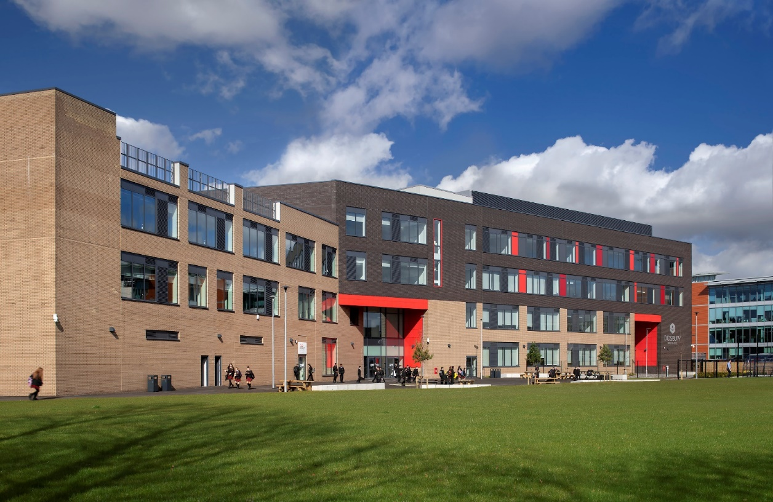

My Difficulties:

Any additional diagnoses: (ADHD, Autism etc)

Neurodiverse needs:
- Sensory passport to be attached if relevant
- Communication cards to be attached

The impact of these difficulties in the classroom/ at school:

Social, emotional, and mental health needs and support strategies.

Green:  X is managing  How you can tell that X is managing- what this looks like: | Needs for success in the classroom:  Table on own  Time out card  Exit area  Specific person  Fidget toys etc | Supportive actions:  Check-in from staff member
Amber:  X is struggling  How you can tell that X is struggling- what this looks like: | Needs for success in the classroom:  Offer time out  Offer distraction task  Grounding activity  Mindfulness activity | Supportive actions:  Sitting alongside young person  Quiet encouragement  Acknowledging struggle
Red:  X is in crisis  How you can tell that X is struggling- what this looks like: | Needs for success in the classroom:  Removal to quiet area  Ice Pack | Supportive actions:  Reflection time at a later date

Contact details of relevant teams:

Team: | Contact details:

Useful resources:

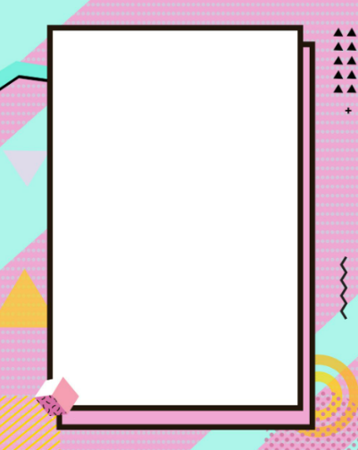
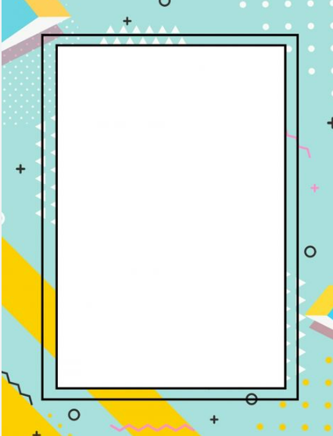
Below are some helpful resources and websites to access further support.
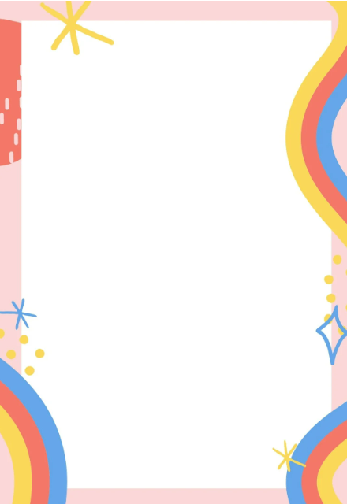
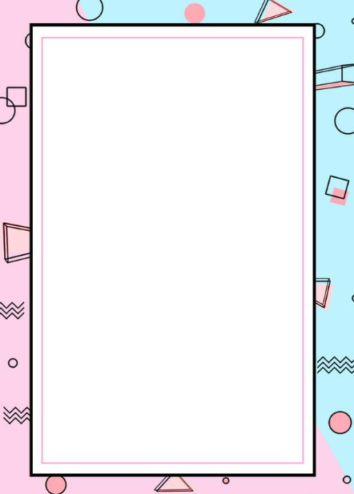
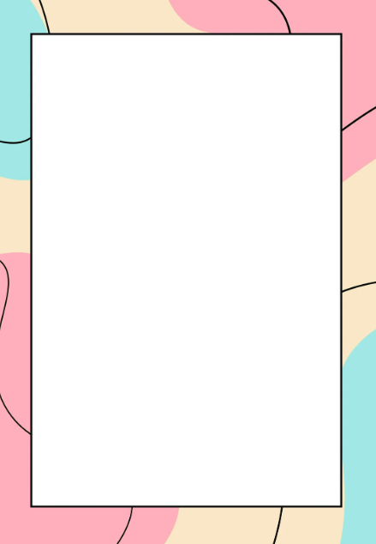
www.b-eat.co.uk
Beat is a website dedicated to supporting individuals with Eating Disorder
Mental health and emotional wellbeing | Barnardo's (barnardos.org.uk)
Mental health service for children and young people.
The Mix - Essential support for under 25s
Support service for young people. To get support for any challenges, such as mental health, money or emotional support through helpline number or counselling service.
Wellbeing & Mental Health Support for young people (stepbystep.org.uk)
Offers 1:1 support for anyone under the age of 25 years old.
YoungMinds | Mental Health Charity For Children And Young People | YoungMinds
Is the UK’s leading charity committed to improve the emotional well-being and mental health of children and young people.

